

**Lesson 5: Turtle Shapes**

**Summary:**

|  |  |
| --- | --- |
| **Code Instruction** | **What it does** |
| **1**  **t=turtle.Turtle()** | **Set turtle costume as a small arrow shape** |
| **2**  **t=turtle.Turtle(‘classic’)**  **or**  **t=turtle.Turtle()**  **t.shape(‘classic’)** | **Set turtle costume as a small arrow shape** |
| **3**  **t=turtle.Turtle(‘turtle’)**  **or**  **t=turtle.Turtle()**  **t.shape(‘turtle’)** | **Set turtle costume as a turtle shape** |
| **4**  **t=turtle.Turtle(‘circle’)**  **or**  **t=turtle.Turtle()**  **t.shape(‘circle’)** | **Set turtle costume as a circle shape** |
| **5**  **t=turtle.Turtle(‘square’)**  **or**  **t=turtle.Turtle()**  **t.shape(‘square’)** | **Set turtle costume as a square shape** |
| **6**  **t=turtle.Turtle(‘triangle’)**  **or**  **t=turtle.Turtle()**  **t.shape(‘triangle’)** | **Set turtle costume as a triangle shape** |
| **7**  **t=turtle.Turtle(‘arrow’)**  **or**  **t=turtle.Turtle()**  **t.shape(‘arrow’)** | **Set turtle costume as an arrow shape** |
| **8**  **t.shapesize(value)**  **t.shapesize(1)**  **t.shapesize(3)** | **Set the size value of the turtle shape** |
| **9**   1. **t.shapesize(value1,value2)**   **Example**  **t.shape(‘circle’)**  **t.shapesize(1,3)** | **Set width value=value1 and length value=value2** |
| **10 t.shapesize(value1,value2,value3)**  **Example**  **t.turtle(‘square’)**  **t.shapesize(2,2)**  **t.shapesize(2,2,10)** | **Set width value=value1, length value=value2 and value3 determines the width of the shape’s outline** |
| **11**  **t.sharefactor(value)**  **Example**  **t.shape(‘square’)**  **t.shapesize(3)**  **t.shearfactor(0.4)** | **Distorts the image shape, value should be between -1 and 1** |

**Keep in mind!**

**With free of charge Trinket software:**

**Options 2-7 of Summary work only with two lines**

**Options 8, 9, 10, 11 work only with Pygame Trinket option, which costs $3 (USA) per month. In this case at the end of the program you have to add the following line**

**input()**

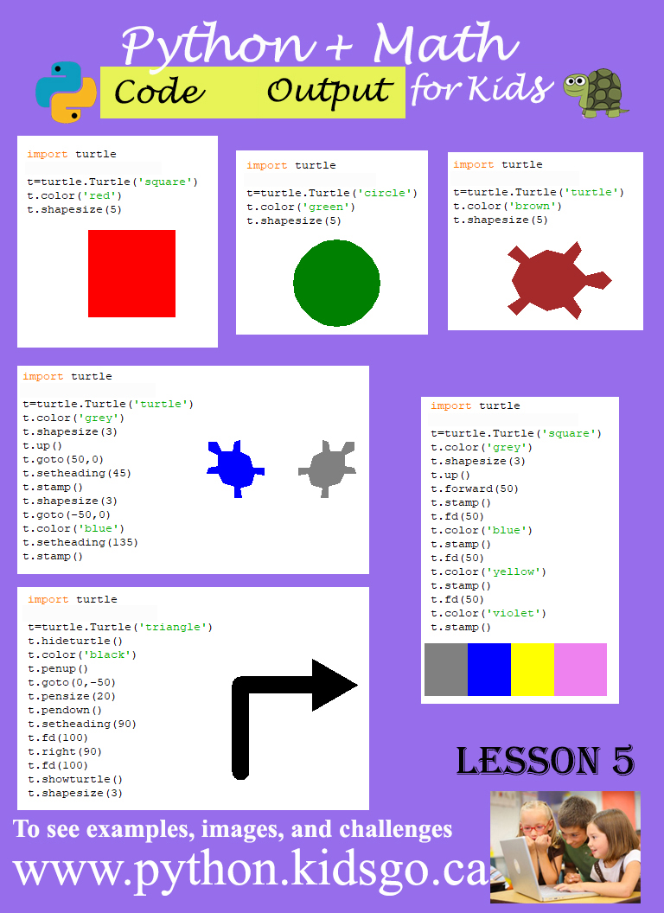

1. **Example #1** (rectangle with square shape)

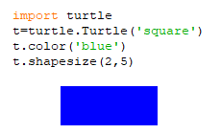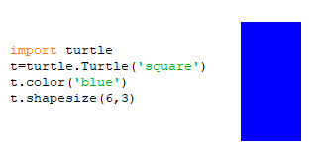

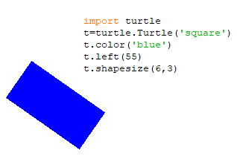

1. **Example #2** (Draw snowflake).

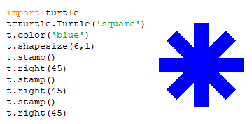

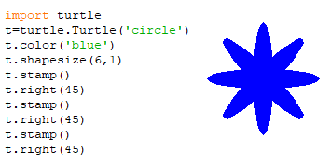

1. **Example #3** (Snowflakes)

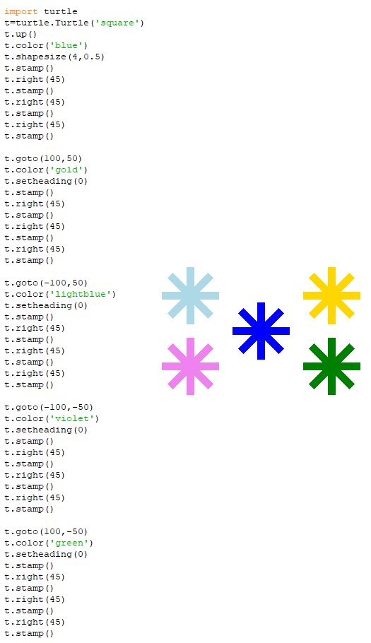

1. **Example #4** (Nice Face)

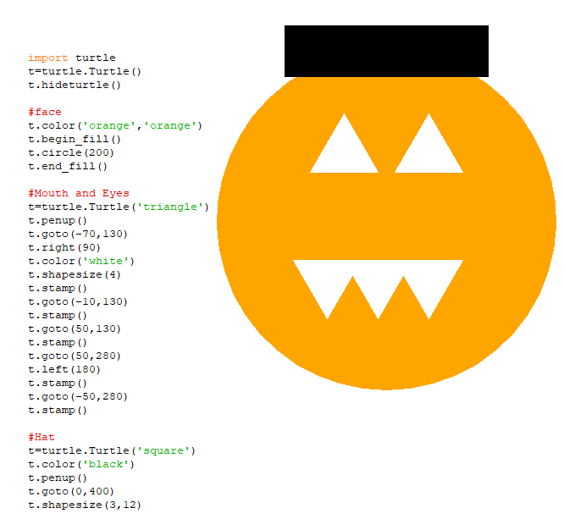

Challenges: write codes to create the following geometry shapes with circle code:

1. Expected output

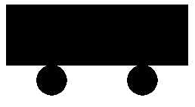

1. Expected output

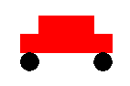

1. Expected output



1. Expected output (Choose colour black and grey)



1. Expected output



1. Expected output

